SPECTRAL PG 52

Swing Grinding Machine
for fast spectroscopic sample preparation of iron and steel samples, bench top compact design, closed
housing, max. safety provided with interlocking switch, robust column mounted in taper roller bearings,
low noise with motor of 3 kW and 2800 rpm, with electronic brake system and overload protection, extraordinary access with sliding door, easy handling with sample swing movement from the front side of the machine, vertical precision positioning of the grinding head with an accuracy of 0.01 mm, large working space with LED lamp, standard outlet for dust exhauster, sample cooling available with water cooling and/or compressed air, complete and ready for operation. Standard packing included. Without clamping devices. Without cooling tank.
400V, 3-phase, 50 Hz.

Technical Specifications
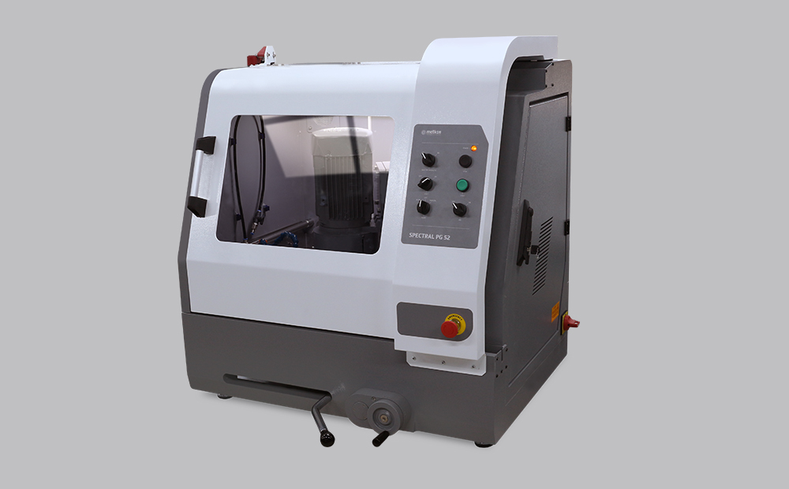
ORDER NO | 81 03
MODEL NO | SPECTRAL PG 52
Grinding Motor Power, kW(S1) | 3
Grinding wheel Speed, (rpm) | 2800
Cup wheel diameter, (mm) | Ø150
Radius of Arc | 52
Travel, mm | 203
Z-Axis Stroke, (mm) | 80
Operation | Manual
Dimensions, WxDxH, (cm) | 94 x 83 x 97
Dimensions, WxDxH, (with cabinet, cm) | 94 x 83 x 175
Weight, (kg) | 300
Weight, (with cabinet, kg) | 385

Accessories
Accessories for SPECTRAL PG 52
GR 1943 | Mechanical 3-Jaw Chuck
GR 1801 | Mechanical clamping device for samples up to 60 mm.
GR 1948 | Universal Jaws for Mechanical clamping Device (GR 1801)
GR 1949 | Jaws for Thin specimens for Mechanical clamping Device (GR 1801)
GR 1942 | Permanent Magnetic Clamping Device, 100x150 mm.
GR 1820 | Electromagnetic clamping plate
GR 1907 | Floor Cabinet for Spectral PG 52/MM 102/ AG 102
GR 1945 | Recirculating coolant tank, stainless steel, 55 lt capacity, with pump, hoses etc.
YM 8813 | Fine filter sheets for recirculation cooling tank (GR 1945), 10 pcs.
GR 1540 | Magnetic Collector rod, for reciculation cooling tank
GR 1397-00 | Water Filtering and Pressure Regulator System for city water inlet.
 | Keeps the water pressure at the appropriate level and protects from sudden
 | pressure spikes. Filtering out impurities in the water and prevents calcification.
YM 3824-00 | Spare Siliphos Cartridge Filter
 | (for Water Filtering and Pressure Regulator System (GR 1397-00))
Spare Part Kit for SPECTRAL PG 52
GR 1944 | Recommended Set of Spare Parts, SPC PG 52

Consumables
Grinding Stones for SPECTRAL PG 52 /AG 102 (1 Pc)
GSW 60 | 80-150 | AL2O3 Grinding Stone, 60 grit, for medium hard steels, Dia. 150/32 mm
GSR 60 | 80-151 | AL2O3 Grinding Stone, 60 grit, for hard steels & cast iron, Dia. 150/32 mm
GSW 36 | 80-155 | AL2O3 Grinding Stone, 36 grit, for medium hard steels, Dia. 150/32 mm
GSR 36 | 80-156 | AL2O3 Grinding Stone, 36 grit, for hard steels & cast iron, Dia. 150/32 mm

