Description

Abrasive Cutting Machine
Microprocessor controlled, front panel with touch-pad controls, compact powerful 3 kW motor, electronic brake system, cutting capacity up to 115/90 mm solid stock, for cut-off wheels up to Ø300/250 mm, twin T-slotted clamping table 255x250 mm made of stainless steel, bottom part as rugged alloy base casting, ABS protective hood, Ready for operation. Without clamping devices, without recirculation cooling tank. 400 V, 3 phase, 50 Hz.
Includes a standard set of cutting consumables composed of;
*1 pack of medium type 10 cut-off wheels 250 mm dia.
*1 pack of medium type 10 cut-off wheels 300 mm dia.
*5 lt of METCOOL cooling fluid.

Technical Specifications
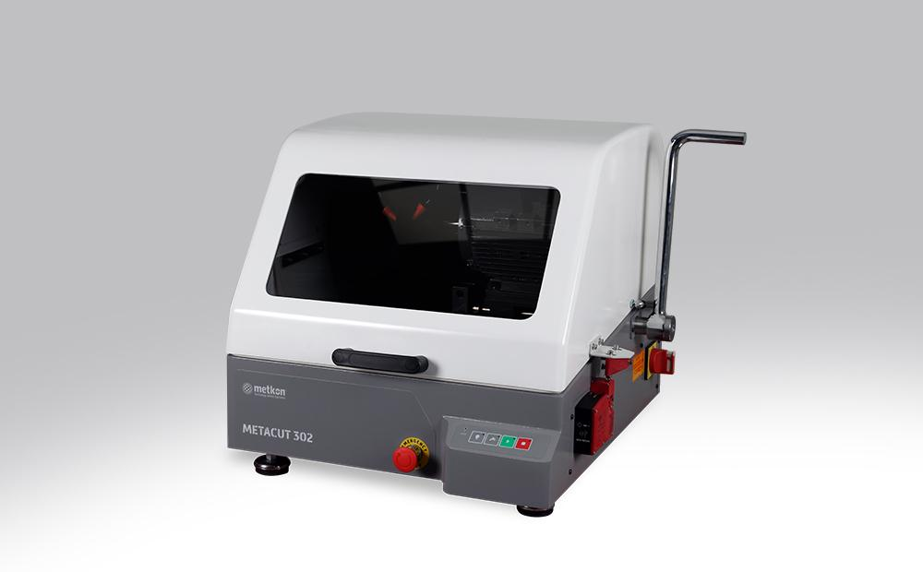
ORDER NO | 10 05
MODEL NO | METACUT 302
Cutting Power kW(S1) | 3
Wheel Speed, rpm | 2800
Operation | Manual
Wheel Diameter, (mm) | Ø300 / Ø250
Cutting Capacity, ø (mm) | Ø115 / Ø90
Cutting Capacity, # (mm) | 50 x 195 / 50 x 165
T-Slot table dimension, (mm) | 255 x 250
T-Slot dimension, (mm) | 12
Size, WxDxH, (cm) | 58 x 68 x 49
Weight, (kgs) | 132
Cooling Unit, (lt) | 60
Mains, (V) | 3 phase 400 V, 50 Hz

Accessories
Cooling System for METACUT 302
GR 0019 | Recirculation Cooling Tank, 60 lt, for METACUT 302 / Forciplan 102
YM 8813 | Fine filter sheets for recirculation cooling tank (GR 0019/GR 1675/ GR 1945), 10 pcs
GR 1540 | Magnetic collector rod for recirculation cooling tank
Clamping Devices for METACUT 302
GR 0012 | Quick Acting Clamping Vise Assembly, Right, for MTC 302 (Stainless Steel)
GR 0013 | Quick Acting Clamping Vise Assembly, Left, for MTC 302 (Stainless Steel)
GR 0151 | Compact Vise Assembly, Spring Loaded, for MTC 302/SRC 302 (Stainless Steel)
15 01 | MBU 1011 Vertical Clamping Device with clamping shoe, clamping height up to 90 mm.
15 03 | MK 10 21 Height Block, 60 mm
GR 0453 | Fastener vise for longitudinal sectioning of screws, fasteners tubes, etc.  from 12 to 45 mm in length
Accessories for METACUT 302
GR 0939 | Cabinet for floor model, MTC 302
Spare Part Kit for METACUT 302
GR 1962 | Recommended Set of Spare Parts, METACUT 302

Consumables
Treno Series Abrasive Cut-off Wheels (Pack of 10)
TRENO-Ti | 19-019 | Ø 250 mm, for Titanium and Very Ductile Materials
TRENO-NF | 19-020 | Ø 250 mm, for Non-Ferrous Steels
TRENO-H | 19-021 | Ø 250 mm, for Soft Steels < 23 HRC
TRENO-M | 19-022 | Ø 250 mm, for Medium Hard Steels > 23-55 HRC <
TRENO-S | 19-023 | Ø 250 mm, for Hard Steels > 50-60 HRC <
TRENO-SS | 19-024 | Ø 250 mm, for Very Hard Steels > 60 HRC
TRENO-NF | 19-040 | Ø 300 mm, for Non-Ferrous Steels
TRENO-H | 19-041 | Ø 300 mm, for Soft Steels < 23 HRC
TRENO-M | 19-042 | Ø 300 mm, for Medium Hard Steels > 23-55 HRC <
TRENO-S | 19-043 | Ø 300 mm, for Hard Steels > 50-60 HRC <
TRENO-SS | 19-044 | Ø 300 mm, for Very Hard Steels > 60 HRC
Long Life Abrasive Cut-off Wheels (Pack of 10)
TRENO-DUR | 19-026 | Ø 250 mm, for Extremely Low Consumption Rate with Optimum Surface
 |  | Quality for High Volume Cutting Operations, Cut-Check Applications, etc..
Ultra Thin Abrasive Cut-off Wheels (Pack of 10)
TRENO-HT | 19-031 | Ø 250 mm, 1.0 mm thickness, for Soft Steels > 20-35 HRC <
TRENO-MT | 19-032 | Ø 250 mm, 1.0 mm thickness, for Soft&Medium Hard Steels >38-58 HRC<
Cuto Series Abrasive Cut-off Wheels (Pack of 10)
CUTO-M | 19-022/A | Ø 250 mm, for Soft&Medium Hard Steels up to 50HRC
CUTO-S | 19-023/A | Ø 250 mm, for Hard Steels > 50-60 HRC <
CUTO-M | 19-042/A | Ø 300 mm, for Soft&Medium Hard Steels up to 50HRC
CUTO-S | 19-043/A | Ø 300 mm, for Hard Steels > 50-60 HRC <
Diamond Cut-off Wheels (1 pc) for METACUT & SERVOCUT
DIMOS | 19-250 | ø 250 Diamond Cut-off wheels (Metal Bonded, high conc.)
DIMOS | 19-251 | ø 250 Diamond Cut-off wheels (Resin Bonded, high conc.)
DIMOS | 19-300 | ø 300 Diamond Cut-off wheels (Metal Bonded, high conc.)
DIMOS | 19-301 | ø 300 Diamond Cut-off wheels (Resin Bonded, high conc.)
Cutting Fluid
METCOOL | 19-902 | Nature Friendly Soluble Oil, 5 lt.
METCOOL II | 19-905 | Nature Friendly Soluble Oil, 1 lt.
METCOOL-NF | 19-906 | Nature Friendly Soluble Oil, 5 lt.
 |  | Perfect corrosion protection for reactive metals like copper, brass,
 |  | cobalt, aluminum, tungsten carbide, etc…

