ECOPRESS 102

Programmable Automatic Mounting Press
7" HMI touch screen control, with Siemens PLC control unit, programmable with colored LCD display, program based mounting sequences, electro hydraulic pressure (requires no air), pressure up to 300 bar, temperature up to 200⁰C, operation time up to 35:00 minutes, short cycle time, thermostatically controlled heating power of 1650W, automatic cooling cycle with three modes of cooling rates(standard cooling, slow cooling and based on time), programmable preheating and preloading, stand-by temperature, selectable mould sizes from 25 mm to 50 mm, easy to close bayonet closure, audible warning signal, ready for operation. 230 V, 1-phase, 50/60 Hz. Mould assemblies are ordered separately.
Includes a standard set of mounting consumables composed of
3 different hot mounting compounds; 1 kg of each and a total of 3 kg.

Technical Specifications
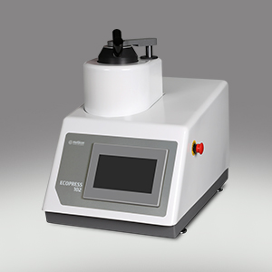
ORDER NO | 25 07
MODEL NO | ECOPRESS 102
Max. Pressure, bar | 300
Max. Temperature, C | 200
Heating Power, W | 1650
Water Cooling | Yes
Slow Cooling | Yes
Operation | Programmable/Hydraulic
Display | 7” HMI touch screen LCD
Mould Assembly, mm | 25-50
Size W x D x H, (cm) | 36x 55x 48
Weight, (kg) | 38

Accessories
Mould Assemblies
26 01-03 | Mould assembly, Ø1" with intermediate ram
26 02-03 | Mould assembly, Ø1 1/4" with intermediate ram
26 03-03 | Mould assembly, Ø1 1/2" with intermediate ram
26 07-03 | Mould assembly, Ø2" with intermediate ram
26 04-03 | Mould assembly, Ø25 mm with intermediate ram
26 05-03 | Mould assembly, Ø30 mm with intermediate ram
26 06-03 | Mould assembly, Ø40 mm with intermediate ram
26 08-03 | Mould assembly, Ø50 mm with intermediate ram
26 11-03 | Mould assembly, Ø1" with chamfered bottom ram and intermediate ram
26 12-03 | Mould assembly, Ø1 1/4" with chamfered bottom ram and intermediate ram
26 13-03 | Mould assembly, Ø1 1/2" with chamfered bottom ram and intermediate ram
26 17-03 | Mould assembly, Ø2" with chamfered bottom ram and intermediate ram
26 14-03 | Mould assembly, Ø25 mm with chamfered bottom ram and intermediate ram
26 15-03 | Mould assembly, Ø30 mm with chamfered bottom ram and intermediate ram
26 16-03 | Mould assembly, Ø40 mm with chamfered bottom ram and intermediate ram
26 18-03 | Mould assembly, Ø50 mm with chamfered bottom ram and intermediate ram
Accessories for ECOPRESS
GR 1363 | Recirculating Coolant System
 | composed of 40 liters stainless steel cooling tank,
 | 24V recirculating pump and connection hoses, etc.
29-601 | Stainless steel clips (100 pcs)
29-602 | Plastic clips (100 pcs)
29-603 | Plastic multi-clips for 6 specimens (50 pcs)
GR 1397-00 | Water Filtering and Pressure Regulator System for city water inlet.
 | Keeps the water pressure at the appropriate level and protects from sudden
 | pressure spikes. Filtering out impurities in the water and prevents calcification.
YM 3824-00 | Spare Siliphos Cartridge Filter
 | (for Water Filtering and Pressure Regulator System (GR 1397-00))
Spare Part Kit for ECOPRESS
GR 1967 | Recommended Set of Spare Parts, ECOPRESS Series

Consumables
Hot Mounting Powder
BAK-B | 29-001 | Black Phenolic Powder, 1 kg.
BAK-B | 29-001/10 | Black Phenolic Powder, 10 kgs
BAK-B | 29-001/20 | Black Phenolic Powder, 20 kgs
BAK-R | 29-002 | Red Phenolic Powder, 1 kg
BAK-R | 29-002/10 | Red Phenolic Powder, 10 kgs
BAK-R | 29-002/20 | Red Phenolic Powder, 20 kgs
BAK-S | 29-003 | Light Brown Phenolic powder, 1 kg
BAK-S | 29-003/10 | Light Brown Phenolic powder, 10 kgs
BAK-S | 29-003/20 | Light Brown Phenolic powder, 20 kgs
NET | 29-010 | Transparent Acrylic Powder, 1 kg
NET | 29-010/10 | Transparent Acrylic Powder, 10 kgs
EPO | 29-011 | Epoxy, Hard 1 kg
EPO | 29-011/10 | Epoxy, Hard, 10 kgs
DAP | 29-012 | Diallyphtalat, 1 kg
DAP | 29-012/10 | Diallyphtalat, 10 kgs
CON | 29-013 | Conductive Bakelite powder, 0.5 kg
SMOOTH | 29-099 | Mould Release Spray Can, 400 ml

Features
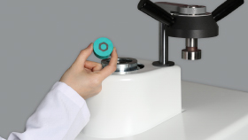 |  | 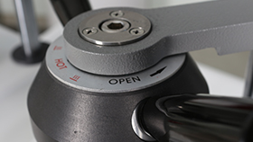 |  | 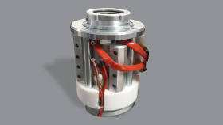
Fast, Simple and Reliable Operation! |  | Double Click System |  | Powerful and Realible Heating System
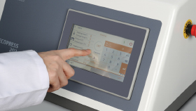 |  | 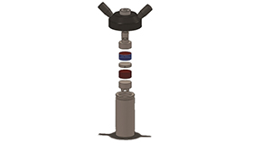 |  | 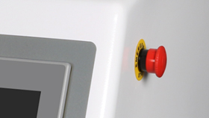
Advanced Mounting Features With Touch Screen |  | Double the Capacity With Intermediate Rams |  | Improved Operator Safety

