SERVOCUT 402-AA

Automatic Abrasive Cutting Machine
Programmable with 7" HMI touch screen control, with Siemens PLC control unit, with automatic chop cutting and automatic table-feed cutting systems, with various cutting methods, programmable with colored LCD display of cutting parameters, accurate and motorized positioning of the specimen in X - Y and Z axis (X-axis for plane parallel cutting is optional), ergonomic joystick with adjustable speed control, integrated feed path control, power dependent adjustable feed rate, variable cutting force, pulse cutting mode, bar graph overload display, powerful 7.5 kW cutting motor, with unique belt protection system, with variable cutting speed 600-3200 rpm, with electronic brake system, cutting capacity up to 150/130 mm solid stock, with cut-off wheels up to Ø400/350mm, twin T-slotted table(Y-direction only) made of stainless steel, bottom part as rugged alloy base casting, extraordinary access for easy handling with sliding door and side openings, with extra advanced cutting methods: "Rapid Pulse Cutting, Table Oscillation Cutting, Instafeed Cutting, Automatic Chop Cutting, Automatic Table Feed Cutting, Joystick Cutting" Ready for operation. Without clamping devices, without recirculation cooling tank.
Includes a standard set of cutting consumables composed of;
*An assortment of 20 cut-off wheels with 400 mm dia.
*5 lt of Metcool cooling fluid.
400 V, 3 phase, 50/60 Hz.

Technical Specifications
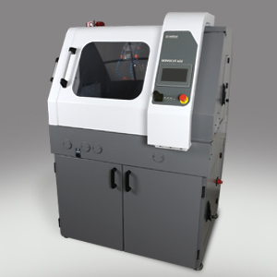
Order No | 15 67 | 15 67-AX
Model | 402-AA | 402-AA-AX
Max. Wheel Diameter | Ø400 mm | Ø400 mm
Max. Cutting Capacity, Ø | Ø150 mm | Ø150 mm
Max. Cutting Capacity, HxD | #85x350 mm | #85x350 mm
Z-Axis Travel, (mm) | 255 | 255
Y-Axis Travel, (mm) | 300 | 300
X-Axis Travel, (mm) | - | 150
T-Table Dimension, (mm) | 550x484 | (446+150)x484
T-Slot Dimension, (mm) | 12 mm | 12 mm
Cutting Motor Power (S1) | 7.5 kW | 7.5 kW
Wheel Speed, RPM | 600-3200 | 600-3200
Cutting Feedrate, (µm/s) | 20-5000 | 20-5000
HMI Touch Screen | 7 inch | 7 inch
Chop Cutting, Z- Axis | Auto | Auto
Table Feed Cutting, Y-Axis | Auto | Auto
Parallel Cutting, X-Axis | - | Auto
Table Oscillating Cutting | Standard | Standard
Rapid Pulse Cutting | Standard | Standard
Smart Feed Control | Standard | Standard
StepCut; SegmentCut; DiagonalCut | Optional | Optional
Automatic Cleaning System | Optional | Optional
Size WxDxH, (cm) | 114x112x169 | 114x112x169
Weight | 600 kgs | 600 kgs
Recirculation Cooling Unit | 135 lt | 135 lt

Accessories
Additional Cutting Methods for SERVOCUT 402
GR 0925 | Software package for optional cutting methods;
 | *Diagonal Cut
 | *Step Cut
 | *Segment Cut
 | *Combined Cut
Power Supply for SERVOCUT 402
GR 1224 | Transformer kit for 200-240 VAC, 3 phase, 50/60 Hz mains voltage
Cooling Systems for SERVOCUT 402
GR 1544 | Recirculation Cooling Tank, 135 lt, for SERVOCUT 502/402
YM 8815 | Fine filter sheets for recirculation cooling tank (GR 1544), 10 pcs
GR 1559 | Coolant level sensor for recirculation cooling tank
 | Informs operator when coolant level is insufficient. (for MA and AA models)
GR 1540 | Magnetic collector rod for recirculation cooling tank
GR 1560 | BANDCOOL Band Filter Unit for SERVOCUT 502/402/302
 | Band filter conveyor for the automatic collection and disposal
 | of swarfs, with capacity of 115 lt, with fluid level indicator,
 | complete system on wheels, with connection kit.
 | 400V, 3-phase, 50 Hz
YM 8878 | Filter roll for BANDCOOL, 50 m, SRC 302/402/502
Accessories for SERVOCUT 402
GR 1554 | FUMEFILTER Centrifugal Separator
 | Removes coolant mist for better illumination and viewing
 | (To be ordered simultaneously together with the machine order)
YM 8834 | Spare Filter Kit for FUMEFILTER (GR 1554)
GR 0139 | AUTOCLEAN Automatic Cleaning System for cutting chamber
 | (To be ordered simultaneously together with the machine order)
GR 0140 | 3-lights warning beacon with audible signal
 | (To be ordered simultaneously together with the machine order)
GR 0125 | Laser alignment unit
 | (To be ordered simultaneously together with the machine order)
GR 1707 | Manual/Auto Table drive system with electromagnetic clutch(y-axis)
 | (To be ordered simultaneously together with the machine order)
GR 0992-01 | Flange Set with larger diameter, Ø133 mm
GR 0997 | Extension Box for cutting long specimens from the left hand side opening,
 | 50 cm length, for SERVOCUT 402
Clamping Devices for SERVOCUT 402
GR 0029 | Quick Acting Clamping Vise Assembly, Right, for SRC 402 (Stainless Steel)
GR 0030 | Quick Acting Clamping Vise Assembly, Left, for SRC 402 (Stainless Steel)
GR 0154 | Compact Vise Assembly, Spring Loaded, for SRC 402 (Stainless Steel)
15 02 | MBU 1031 Vertical Clamping Device with clamping shoe, clamping height up to 115mm.
15 04 | MK 10 22 Height Block, 70 mm
GR 0310 | Fastener vise for longitudinal sectioning of screws, ball joint, tubes, etc. from 60 to 100 mm in length
GR 0312 | Fastener vise for longitudinal sectioning of screws, ball joint, tubes, etc. from 90 to 150 mm in length
GR 0609 | Serial Clamping Device for clamping multiple specimens from 1 to 2
GR 0612 | Angular Precision Clamping Device in 3-Axis Direction
GR 0033 | Chain spanner set with anchor block
15 00 | V-Block for holding parts above table slots
GR 0615 | Adjustable V-Support, Small (Height Range: 57-67 mm)
GR 0616 | Adjustable V-Support, Medium (Height Range: 65-85 mm)
GR 0617 | Adjustable V-Support, Large (Height Range: 85-115 mm)
GR 0618 | Adjustable V-Support, Extra Large (Height Range: 115-155 mm)
Spare Part Kit for SERVOCUT 402
GR 1964 | Recommended Set of Spare Parts, SERVOCUT 402

Consumables
Treno Series Abrasive Cut-off Wheels (Pack of 10)
TRENO-NF | 19-060 | Ø 350 mm, for Non-Ferrous Steels
TRENO-M | 19-062 | Ø 350 mm, for Medium Hard Steels > 23-55 HRC <
TRENO-S | 19-063 | Ø 350 mm, for Hard Steels > 50-60 HRC <
TRENO-SS | 19-064 | Ø 350 mm, for Very Hard Steels > 60 HRC
TRENO-NF | 19-070 | Ø 400 mm, for Non-Ferrous Steels
TRENO-M | 19-072 | Ø 400 mm, for Medium Hard Steels > 23-55 HRC <
TRENO-S | 19-073 | Ø 400 mm, for Hard Steels > 50-60 HRC <
TRENO-SS | 19-074 | Ø 400 mm, for Very Hard Steels > 60 HRC
Diamond Cut-off Wheels (1 pc) for METACUT & SERVOCUT
DIMOS | 19-400 | ø 400 Diamond Cut-off wheels (Metal Bonded, high conc.)
DIMOS | 19-401 | ø 400 Diamond Cut-off wheels (Resin Bonded, high conc.)
Cutting Fluid
METCOOL | 19-902 | Nature Friendly Soluble Oil, 5 lt.
METCOOL II | 19-905 | Nature Friendly Soluble Oil, 1 lt.
METCOOL-NF | 19-906 | Nature Friendly Soluble Oil, 5 lt.
 |  | Perfect corrosion protection for reactive metals like copper, brass,
 |  | cobalt, aluminum, tungsten carbide, etc…

Features
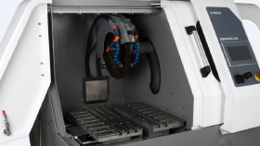 |  | 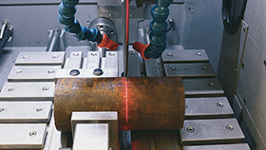 |  | 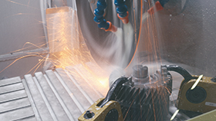
Large Cutting Capacity |  | Powerful Cutting Motor! |  | Efficient Sample Cooling and Filtration
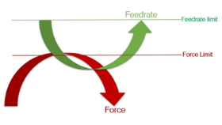 |  | 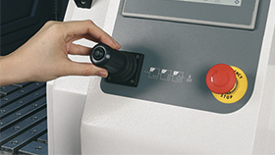 |  | 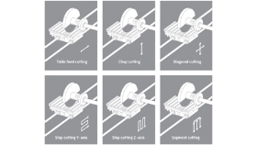
Instafeed Cutting (Auto Feedrate) |  | Joystick Cutting |  | Advanced Cutting Methods
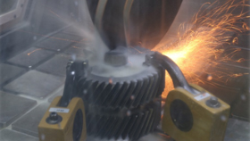 |  | 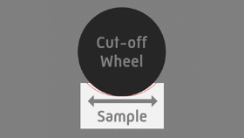 |  | 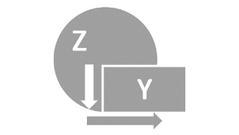
Rapid Pulse Cutting |  | Table Oscillating Cutting |  | Combined Cutting
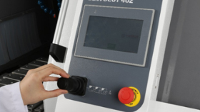 |  | 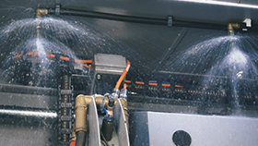 |  | 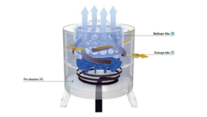
Easy Operation With Touch Screen and Joystick |  | Automatic Cleaning Unit |  | Fumefilter, Fume and Mist Removing Unit

