SERVOCUT 302-AA

Automatic Abrasive Cutting Machine
Programmable with 7" HMI touch screen control, with Siemens PLC control unit, with automatic chop cutting and automatic table-feed cutting systems, with various cutting methods, programmable with colored LCD display of cutting parameters, accurate and motorized positioning of the specimen in X - Y and Z axis (X-axis for plane parallel cutting is optional), ergonomic joystick with adjustable speed control, integrated feed path control, power dependent adjustable feed rate, variable cutting force, pulse cutting mode, bar graph overload display, powerful 4 kW cutting motor, with variable cutting speed 600-4000 rpm, with electronic brake system, cutting capacity up to 110/90 mm solid stock, with cut-off wheels up to ø300/250mm, twin T-slotted table(Y-direction only) made of stainless steel, bottom part as rugged alloy base casting, extraordinary access for easy handling with sliding door and side openings,
with extra advanced cutting methods: "Rapid Pulse Cutting, Table Oscillation Cutting, Instafeed Cutting, Automatic Chop Cutting, Automatic Table Feed Cutting, Joystick Cutting" Ready for operation.
Without clamping devices, without recirculation cooling tank.
Includes a standard set of cutting consumables composed of;
*An assortment of 20 cut-off wheels with 300 mm dia.
*5 lt of Metcool cooling fluid.
400 V, 3 phase, 50/60 Hz.

Technical Specifications
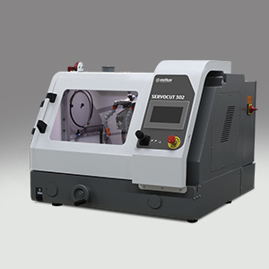
ORDER NO | 15 57 | 15 57-AX
MODEL NO | SERVOCUT 302-AA | SERVOCUT 302-AA-AX
Max. Wheel Diameter | Ø300 mm | Ø300 mm
Max. Cutting Capacity, Ø | Ø110 mm | Ø110 mm
Max. Cutting Capacity, HxD | #70x200 mm | #70x200 mm
Z-Axis Travel, (mm) | 125 | 125
Y-Axis Travel, (mm) | 220 | 220
X-Axis Travel, (mm) | - | 95
T-Table Dimension, (mm) | 444x275 | (395+95)x275
T-Slot Dimension, (mm) | 12 mm | 12 mm
Cutting Motor Power (S1) | 4 kW | 4 kW
Wheel Speed, RPM | 600-4000 | 600-4000
Cutting Feedrate, (μm/s) | 20-5000 | 20-5000
HMI Touch Screen | 7 inch | 7 inch
Chop Cutting, Z- Axis | Auto | Auto
Table Feed Cutting, Y-Axis | Auto | Auto
Parallel Cutting, X-Axis | - | Auto
Table Oscillating Cutting | Standard | Standard
Rapid Pulse Cutting | Standard | Standard
Smart Feed Control | Standard | Standard
StepCut; SegmentCut; DiagonalCut | Optional | Optional
Size WxDxH, (cm) | 94x99x76 | 94x99x76
Weight | 250 kgs | 250 kgs
Recirculation Cooling Unit | 80 lt | 80 lt

Accessories
Additional Cutting Methods for SERVOCUT 302
GR 0925 | Software package for optional cutting methods;
 | *Diagonal Cut
 | *Step Cut
 | *Segment Cut
 | *Combined Cut
Cooling Systems for SERVOCUT 302
GR 1675 | Recirculation Cooling Tank, 80 lt, for SERVOCUT 302
YM 8813 | Fine filter sheets for recirculation cooling tank (GR 0019/GR 1675/GR 1945), 10 pcs
GR 1559 | Coolant level sensor for recirculation cooling tank
 | Informs operator when coolant level is insufficient. (for MA and AA models)
GR 1540 | Magnetic collector rod for recirculation cooling tank
GR 1561 | BANDCOOL Band Filter Unit for SERVOCUT 502/402/302
 | Band filter conveyor for the automatic collection and disposal
 | of swarfs, with capacity of 115 lt, with fluid level indicator,
 | complete system on wheels, with connection kit.
 | 400V, 3-phase, 50 Hz
YM 8878 | Filter roll for BANDCOOL, 50 m, SRC 302/402/502
Accessories for SERVOCUT 302
GR 1681 | Cabinet for floor model - SRC 302/GEOCUT 302
GR 1682 | FUMEFILTER Centrifugal Separator for SRC 302/GEOCUT 302
 | Removes coolant mist for better illumination and viewing
 | (To be ordered simultaneously together with the machine order)
YM 8833 | Spare Filter Kit for FUMEFILTER (GR 1682)
GR 0125 | Laser alignment unit
 | (To be ordered simultaneously together with the machine order)
GR 1680 | Manual/Auto Table drive system with electromagnetic clutch(y-axis)
 | (To be ordered simultaneously together with the machine order)
GR 0991-01 | Flange Set with larger diameter, Ø100 mm
GR 0998 | Extension Box for cutting long specimens from the left hand side opening,
 | 50 cm length, for SERVOCUT 302
Clamping Devices for SERVOCUT 302
GR 0170 | Quick Acting Clamping Vise Assembly, Left, for SRC 302 (Stainless Steel)
GR 0172 | Quick Acting Clamping Vise Assembly, Right, for SRC 302 (Stainless Steel)
GR 0151 | Compact Vise Assembly, Spring Loaded, for MTC 302/SRC 302 (Stainless Steel)
15 01 | MBU 1011 Vertical Clamping Device with clamping shoe, clamping height up to 90 mm.
15 03 | MK 10 21 Height Block, 60 mm
GR 0453 | Fastener vise for longitudinal sectioning of screws, fasteners tubes, etc. from 12 to 45 mm in length
GR 0310 | Fastener vise for longitudinal sectioning of screws, ball joint, tubes, etc. from 60 to 100 mm in length
GR 0612 | Angular Precision Clamping Device in 3-Axis Direction
15 00 | V-Block for holding parts above table slots
GR 0615 | Adjustable V-Support, Small (Height Range: 57-67 mm)
GR 0616 | Adjustable V-Support, Medium (Height Range: 65-85 mm)
Spare Part Kit for SERVOCUT 302
GR 1963 | Recommended Set of Spare Parts, SERVOCUT 302

Consumables
Treno Series Abrasive Cut-off Wheels (Pack of 10)
TRENO-Ti | 19-019 | Ø 250 mm, for Titanium and Very Ductile Materials
TRENO-NF | 19-020 | Ø 250 mm, for Non-Ferrous Steels
TRENO-H | 19-021 | Ø 250 mm, for Soft Steels < 23 HRC
TRENO-M | 19-022 | Ø 250 mm, for Medium Hard Steels > 23-55 HRC <
TRENO-S | 19-023 | Ø 250 mm, for Hard Steels > 50-60 HRC <
TRENO-SS | 19-024 | Ø 250 mm, for Very Hard Steels > 60 HRC
TRENO-NF | 19-040 | Ø 300 mm, for Non-Ferrous Steels
TRENO-H | 19-041 | Ø 300 mm, for Soft Steels < 23 HRC
TRENO-M | 19-042 | Ø 300 mm, for Medium Hard Steels > 23-55 HRC <
TRENO-S | 19-043 | Ø 300 mm, for Hard Steels > 50-60 HRC <
TRENO-SS | 19-044 | Ø 300 mm, for Very Hard Steels > 60 HRC
Long Life Abrasive Cut-off Wheels (Pack of 10)
TRENO-DUR | 19-026 | Ø 250 mm, for Extremely Low Consumption Rate with Optimum Surface
 |  | Quality for High Volume Cutting Operations, Cut-Check Applications, etc..
Ultra Thin Abrasive Cut-off Wheels (Pack of 10)
TRENO-HT | 19-031 | Ø 250 mm, 1.0 mm thickness, for Soft Steels > 20-35 HRC <
TRENO-MT | 19-032 | Ø 250 mm, 1.0 mm thickness, for Soft&Medium Hard Steels >38-58 HRC<
Cuto Series Abrasive Cut-off Wheels (Pack of 10)
CUTO-M | 19-022/A | Ø 250 mm, for Soft&Medium Hard Steels up to 50HRC
CUTO-S | 19-023/A | Ø 250 mm, for Hard Steels > 50-60 HRC <
CUTO-M | 19-042/A | Ø 300 mm, for Soft&Medium Hard Steels up to 50HRC
CUTO-S | 19-043/A | Ø 300 mm, for Hard Steels > 50-60 HRC <
Diamond Cut-off Wheels (1 pc) for METACUT & SERVOCUT
DIMOS | 19-250 | ø 250 Diamond Cut-off wheels (Metal Bonded, high conc.)
DIMOS | 19-251 | ø 250 Diamond Cut-off wheels (Resin Bonded, high conc.)
DIMOS | 19-300 | ø 300 Diamond Cut-off wheels (Metal Bonded, high conc.)
DIMOS | 19-301 | ø 300 Diamond Cut-off wheels (Resin Bonded, high conc.)
Cutting Fluid
METCOOL | 19-902 | Nature Friendly Soluble Oil, 5 lt.
METCOOL II | 19-905 | Nature Friendly Soluble Oil, 1 lt.
METCOOL-NF | 19-906 | Nature Friendly Soluble Oil, 5 lt.
 |  | Perfect corrosion protection for reactive metals like copper, brass,
 |  | cobalt, aluminum, tungsten carbide, etc…

Features
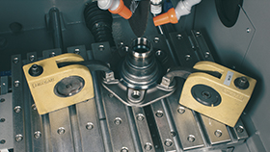 |  | 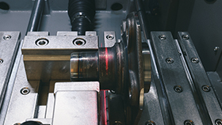 |  | 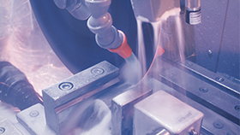
Small Footprint, Large Cutting Capacity |  | Powerful Cutting Motor! |  | Efficient Sample Cooling and Filtration
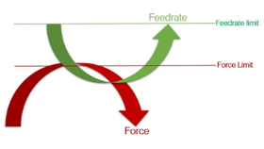 |  | 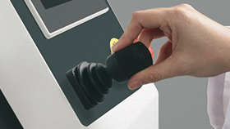 |  | 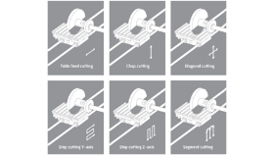
Instafeed Cutting (Auto Feedrate) |  | Joystick Cutting |  | Advanced Cutting Methods
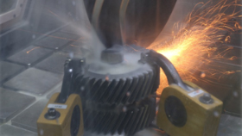 |  | 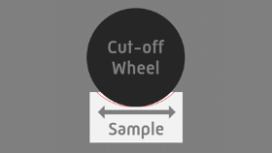 |  | 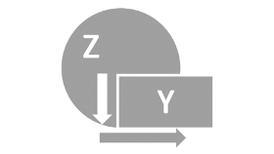
Rapid Pulse Cutting |  | Table Oscillating Cutting |  | Combined Cutting
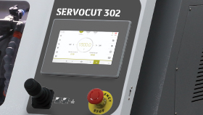 |  | 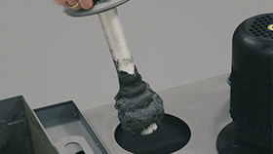 |  | 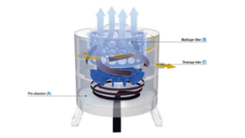
Easy Operation With Touch Screen and Joystick |  | Magnetic Collector Rod Set |  | Fumefilter, Fume and Mist Removing Unit

